Lab Experiment 1:

Aim: Introduction to Packet Tracer , Peer to Peer Communication, Study of Cables and its colour codes.

Procedure:

Step 1: Open Cisco Packet Tracer. Add two computers and one switch to the workspace.
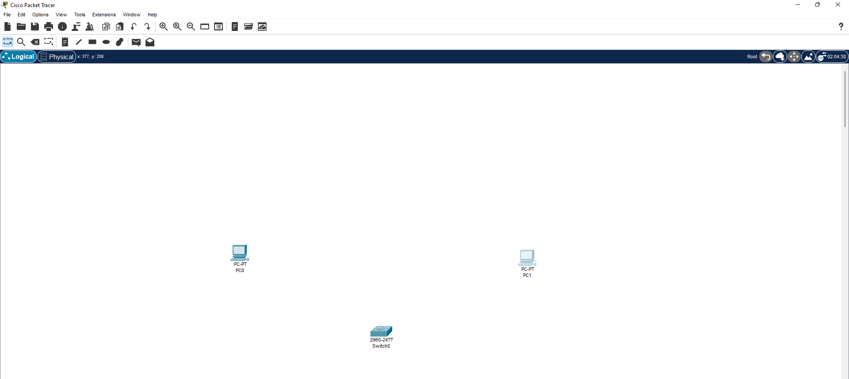

Step 2: Connect both computers to the switch using straight through copper cables.

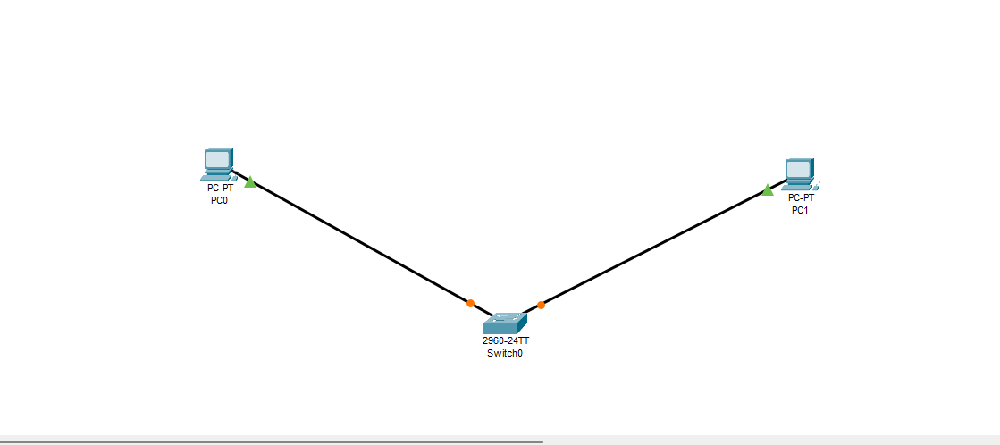

Step 3: Open command prompt on PC0.

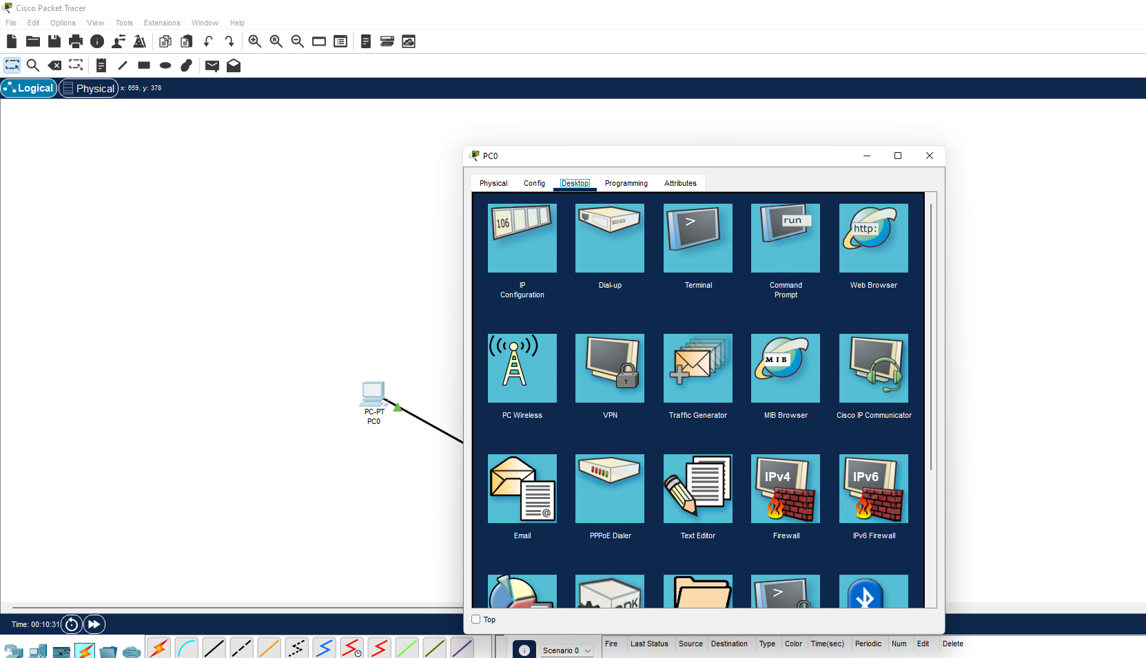

Step 4: Assign IP addresses 192.168.10.1 and set subnet mask.

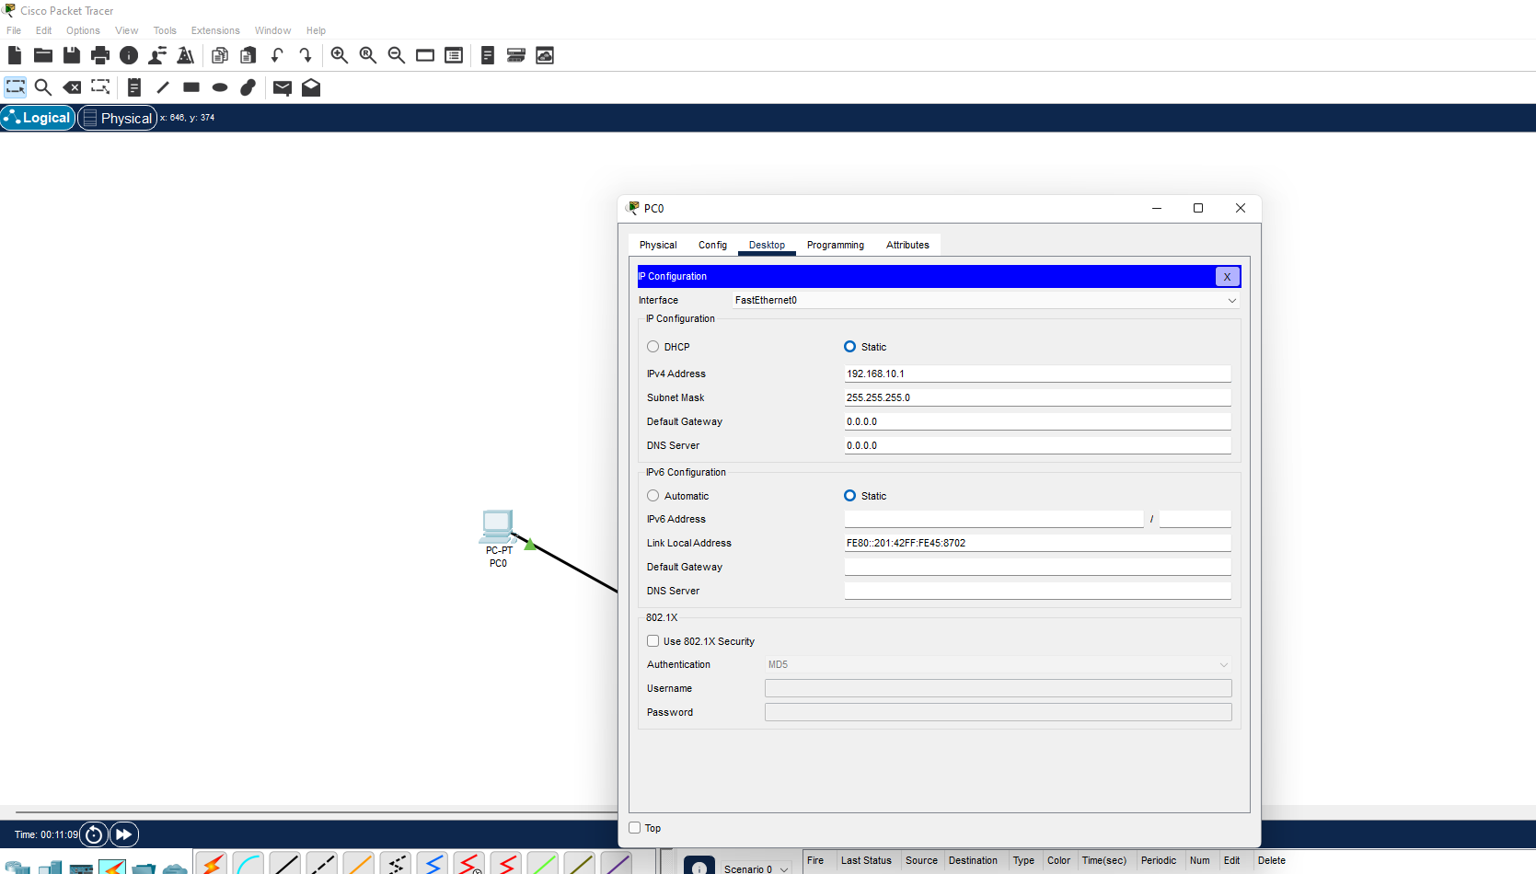

Step 5: Open command prompt on PC1. Assign IP addresses 192.168.10.2 and set subnet mask.

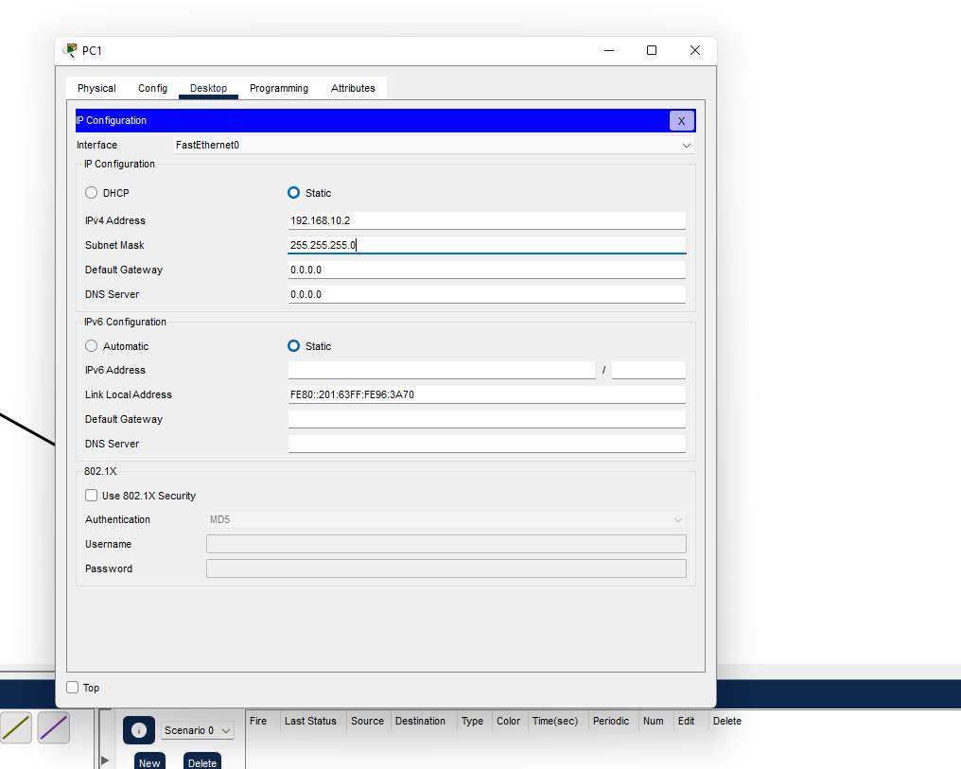

Step 6: Type ping 192.168.10.2 and press enter in PC0.
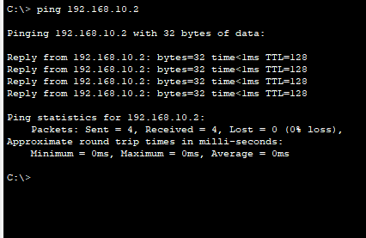

Step 7: Type ping 192.168.10.2 and press enter in PC1.

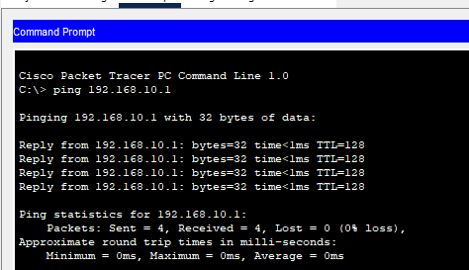

Lab Experiment 2:

Aim: Implementation of Network Topologies

Step 1: Open Cisco Packet Tracer. Add three computers to the workspace. Connect the computers using a single backbone cable to create a bus topology.

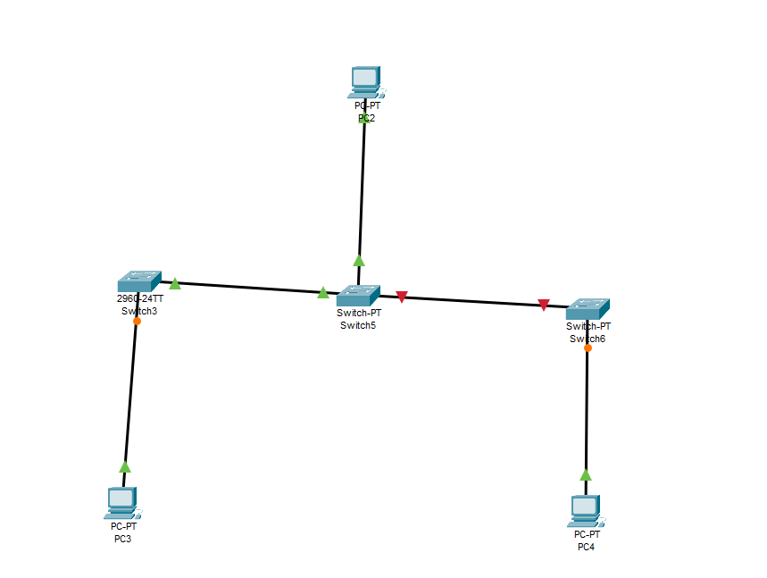

Step 2: Open command prompt on PC3. Assign IP addresses 192.168.10.3 and set subnet mask and do the same for all PCs.

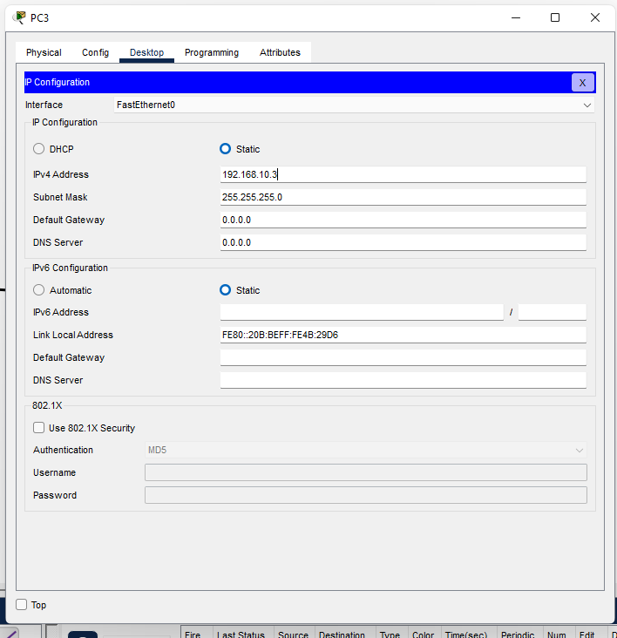

Step 3: Type ping 192.168.10.5 and press enter in PC3.
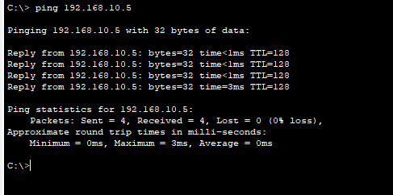

Step 4: Implementation of Star topology by adding a PC and removing two switches.

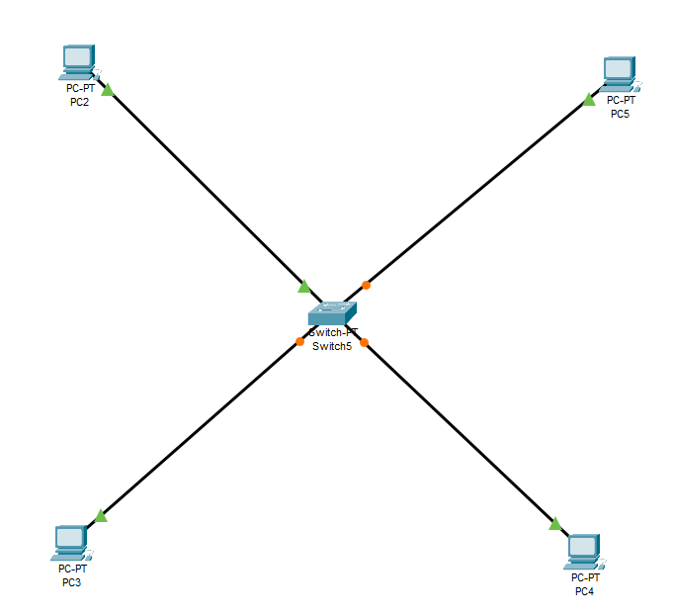

Step 5: Open command prompt on PC5. Assign IP addresses 192.168.10.6 and set subnet mask.

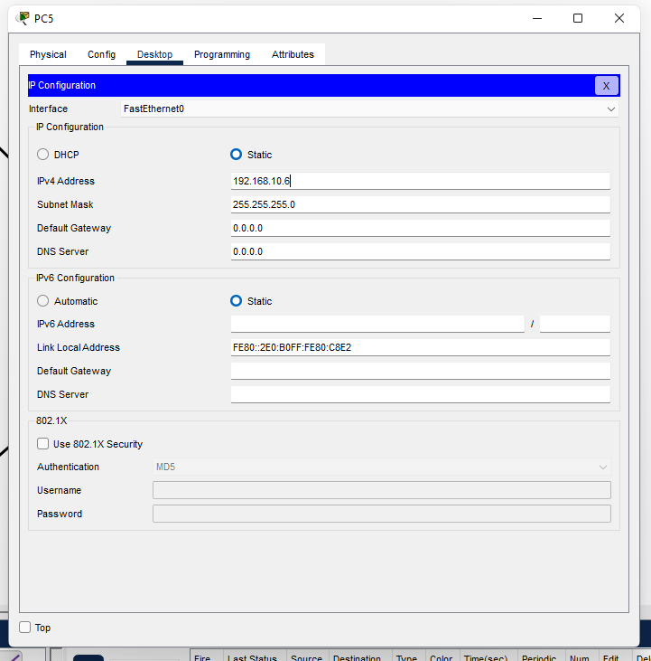

Step 6:Type ping 192.168.10.4 and press enter in PC2.
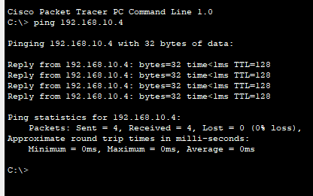

Step 7: Implementation of Ring Topology.

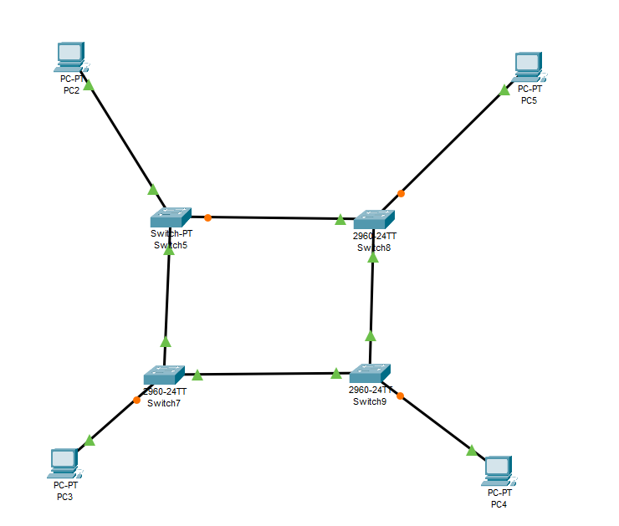

Step 8: Type ping 192.168.10.3 and press enter in PC5.
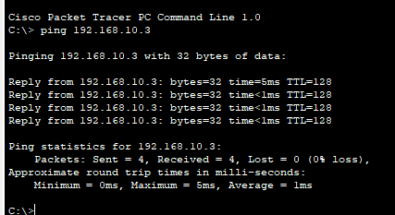

Step 9: Implementation of Mesh Topology.

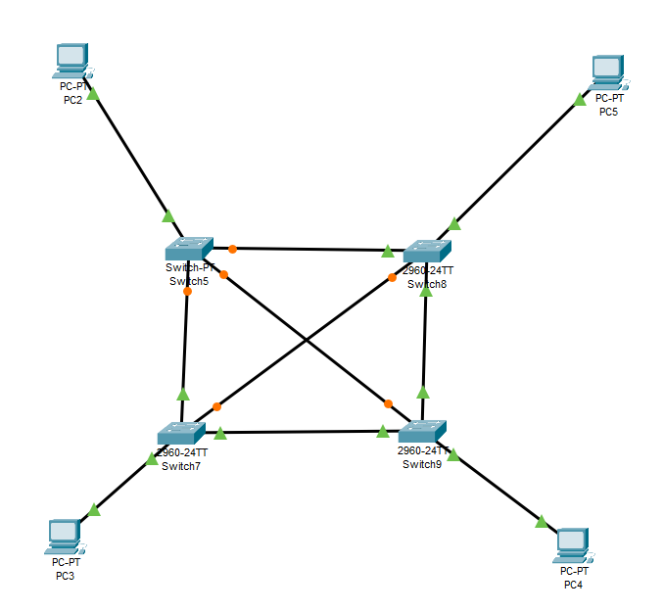

Step 10: Type ping 192.168.10.6 and press enter in PC3.

